Title of the Document: | Pagination in Dashboard
Author: | Roshni Gupta
Project Name:

Table of Contents
Document Description ………………………………………………………………………………………………….… 1
Process flow …………………………………………………………………………………………………………………..1

Document Description:
- Pagination in Dashboard
In this document, How to do pagination in dashboard with the dynamic Page No. and Dynamic Page Size. is described. The detailed process is shown below-
Process Flow:
This is the dashboard where we want to give functionality of pagination.
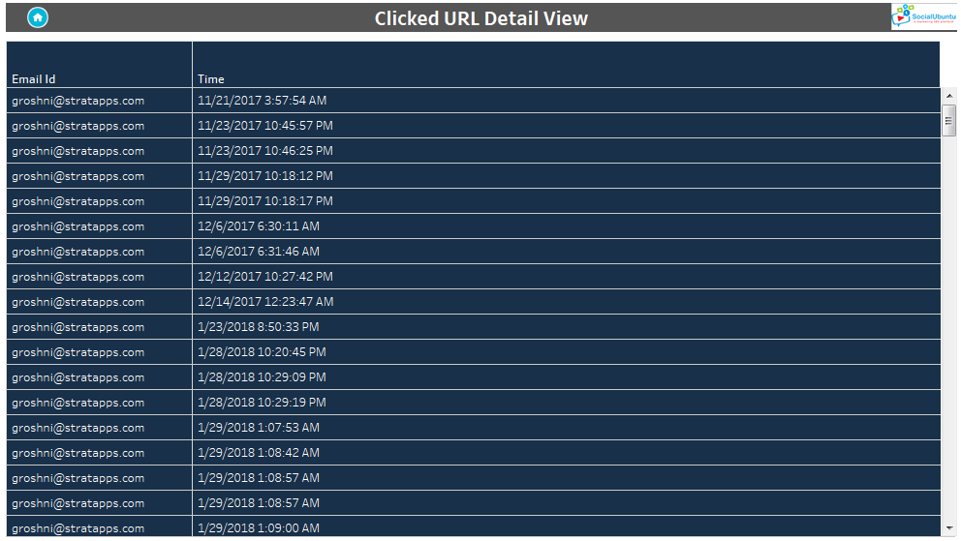

Deployment Steps:
Step 1
Create a dashboard according to your requirement.

Step 2
Go to sheet, as we have ‘Email id’ and ‘Time’ in the row column. We have to create one calculation field for giving the index to email id. And for giving dynamic functionality of page size we need to create one parameter.

Step 3
Create a Parameter with the name of ‘Page Size’ and give data type as ‘Integer’ and allowable values ‘All’ and click ‘OK’.

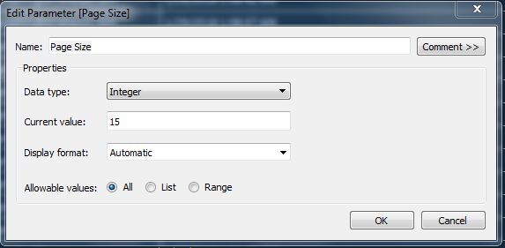

Step 4
Create a calculation field (Named-Page No.) with using this ‘Page Size’ parameter.

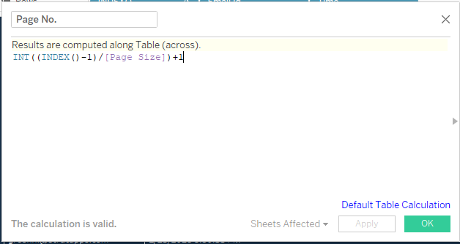

Step 5
Put this calculation field in the filter after converting it into discrete and select 1 in the list.
Step 6
In data pane, select show parameter for page size and in filter shelf show filter for Page No.
Step 7
Go to dashboard and place this both parameter and calculation and select accordingly. It will give you pagination according to user selection.
For Example-
Below 1st screen shot I have selected Page no. 8 and Page size 10 and for 2nd screen shot page no. 2 and Page size 15.
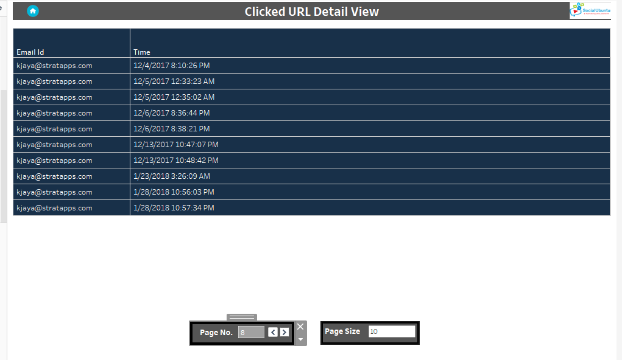
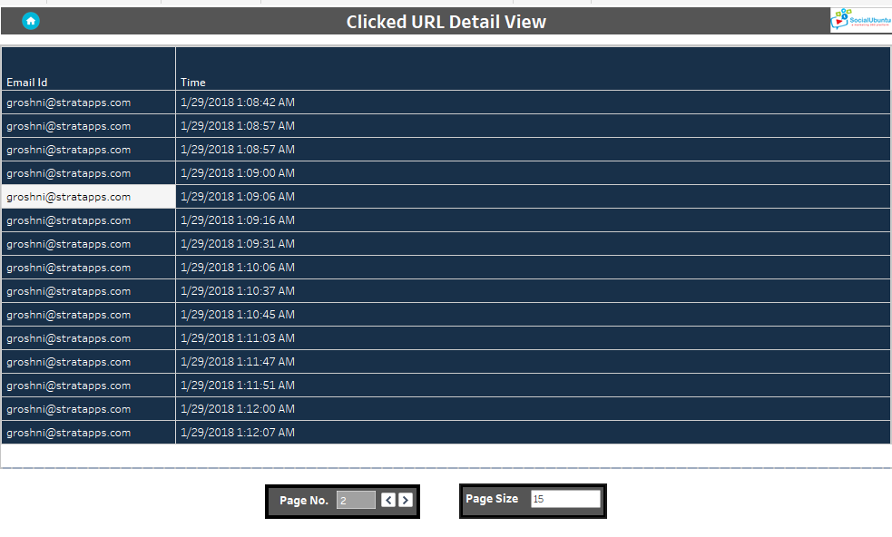
THANK YOU

